# Software Engineering

# COS 301

# Buzz System

# Functional Requirements

# Detect if a post is plagiarised.

5.1 Use case prioritization

Nice-To-Have

5.2 Use case/Services contracts

* Pre-Conditions: the conditions under which the service may be refused (usually there is an exception associated with each pre-condition).
  + All posts from within the website will need to be available for traversal in text format.
  + A reference collection of documents assumed to be valid will need to be obtained for traversal in text format.
  + A similarity threshold will need to be agreed upon.
  + Access to the Internet (not just Intranet) is a must.
  + A google Search Engine ID and API Key for getting RESTful results to get web search results for comparison in JSON format (Google Custom Search Engine – 100 Free Search Queries Per Day)
* Post-Conditions: the conditions which must hold true after the service has been provided.
  + A moderator must be alerted if the plagiarism percentage surpasses the allowed threshold.
  + The percentage of plagiarism detected must be alerted to a moderator if it surpasses the threshold.
  + If plagiarism is detected above the allowed threshold, the post must be highlighted as suspicious.
  + Unique documents scanned must be added to the repository of reference documents.
* 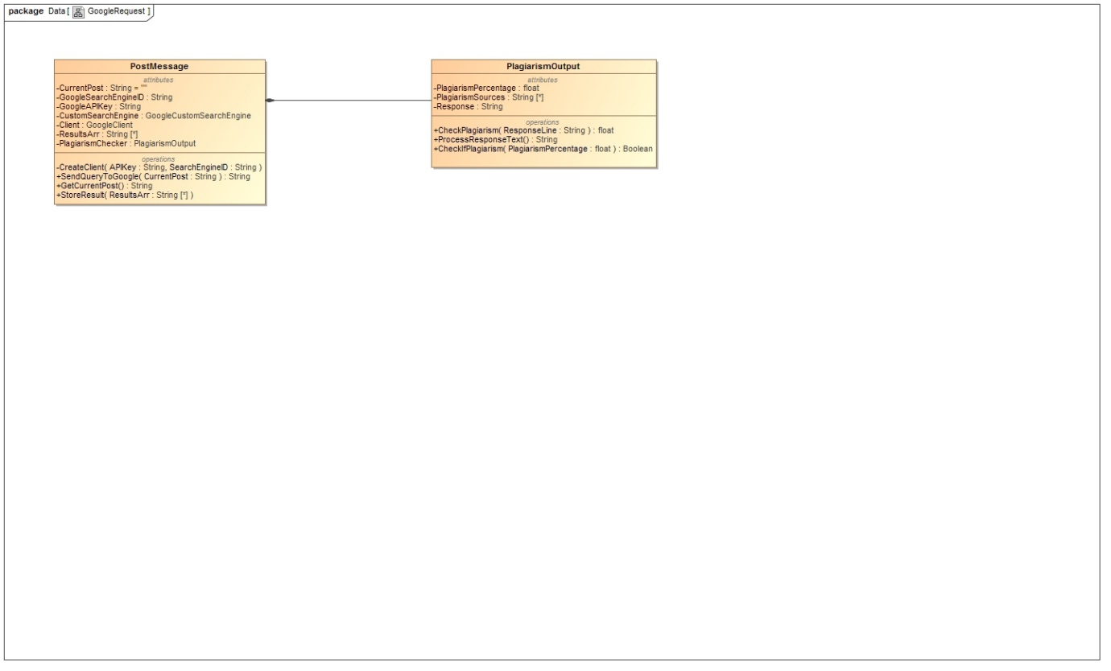Request and Results Data Structures: Use class diagrams to specify the data structure requirements for the request and result objects (i.e. the inputs and outputs).

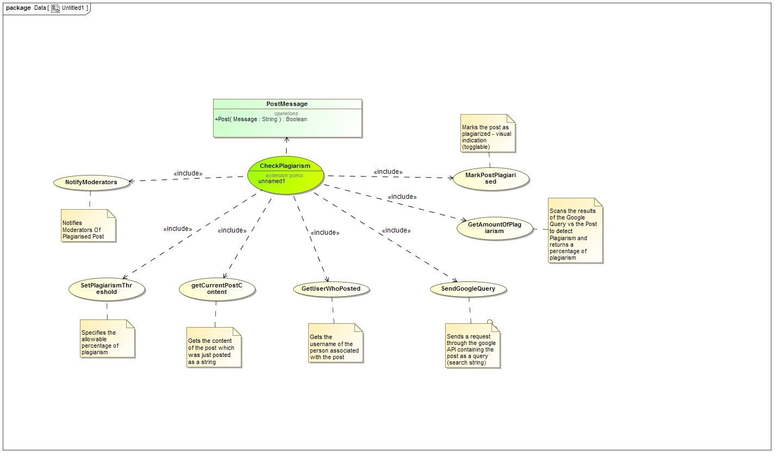5.3 Required functionality

5.4 Process specifications

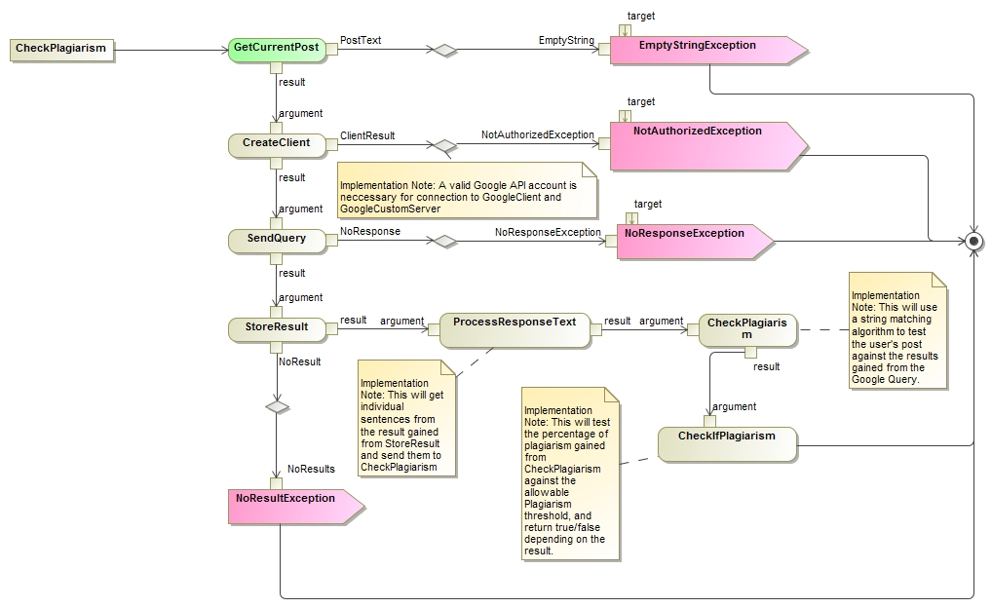

5.5 Domain Model

# Detect violation of netiquette rules.